**In 1976, the city of Toronto modified Exhibition Stadium believing that they were getting an MLB team.** But as we know, that didn’t happen until the following year.

No Place Like Home

**Exhibition Stadium was the very first home of the Blue Jays**. It was built in 1959 primarily for football because Toronto didn’t have an MLB team yet. The only

professional team

to play there was

the Canadian

Football League’s

Toronto Argonauts.

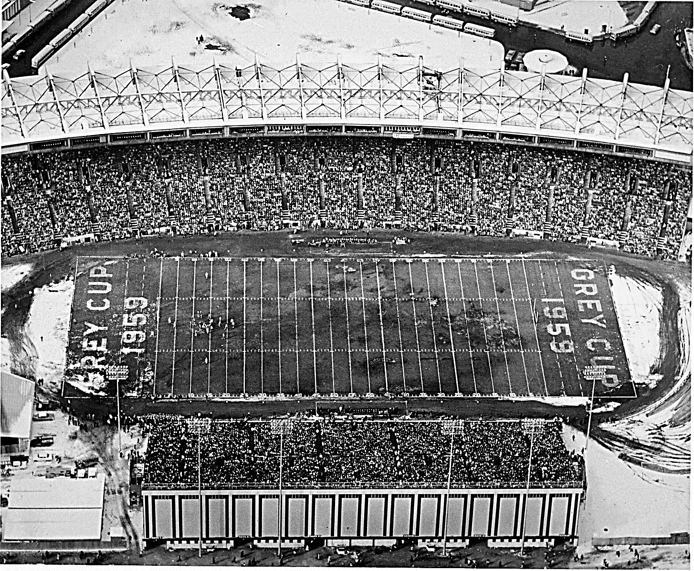

**Want to know an interesting statistic about Exhibition Stadium?**  In all of the MLB games played there, never was there a no-hitter pitched in the stadium.

Did You Know?! On April 7th, the field was snow-covered. So they had to borrow the Zamboni from Maple Leaf Gardens to clean the field off so they could play ball.

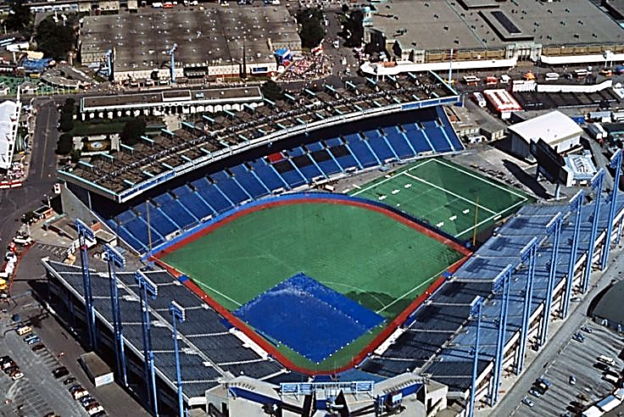

**The Jays’ very first game was**

**played on April 7, 1977 at Exhibition Stadium.** With a capacity of 43 737, the stadium was home of the team till May 28, 1989.