**FERRIS BUELLER’S DAY OFF**

**3**

**RELEASED: June 11, 1986**

**WRITER: John Hughes**

**DIRECTOR: John Hughes**

**BOX OFFICE: $70.1 million**

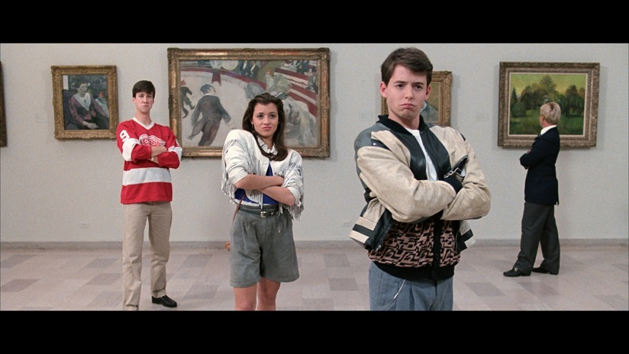

**You’ve endured 13 years of hard labour, you’ve done your time. So, you decide to skip school on your very last week of high school, the longest week of your life: It’s time to celebrate! You deserve a day off!**