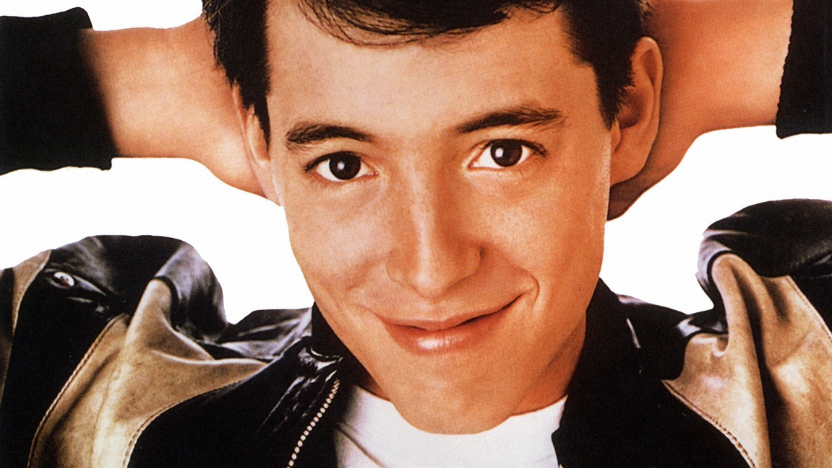

Ferris Bueller’s Day Off

**Ferris’ Second Day Off???**

There was lots of talk about a sequel, but in the end, they decided NO! Ferris Bueller’s Day Off was one day, one period in time. And for that, there’s no possible sequel. To Matthew Broderick, it just didn’t make sense.



**Filming**

John Hughes wrote the screenplay for the movie in 6 days. He called it a “love letter to Chicago” because it features many of the city’s famous landmarks. Filming took place over three months.

In the movie, Ferris tries to convince Cameron to take his father’s prized and rare 1961 Ferrari GT California. Many replicas were made, but for the tight shots they brought a real one in.

**Storyline**

High School senior Ferris Bueller convinces his best friend Cameron and his girlfriend Sloane to jig school with him. Ferris uses his quick wit and schemes to sneak both of his accomplices out of school. And then the rest of the day is theirs’ to play around the city of Chicago. But the Dean is skeptical and tries his best to catch the trio, while they try creatively to avoid getting caught.

**Alan Ruck, who was supposed to be playing a high school senior, was actually 29 years old when the movie was shot.**

Quick Fact



**Awards**

Matthew was nominated for a Golden Globe in 1986 for Best Actor in a Comedy, but Paul Hogan won for his work in “Crocodile Dundee.”

**Actors**

Matthew Broderick - Ferris Bueller, the charming mastermind.

Mia Sara - Sloane Peterson, Ferris’ adventurous girlfriend.

Alan Ruck - Cameron Frye, Ferris’ fearful and timid friend.

Jeffery Jones - Mr. Rooney, the obsessive Dean of Students.

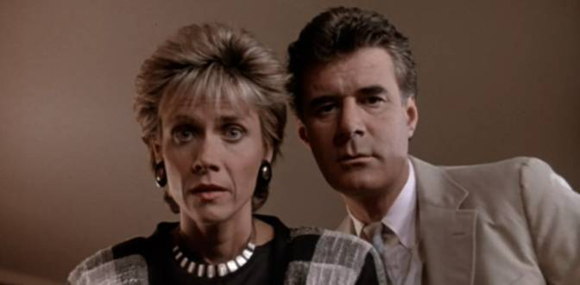

**Love Was In the Air**

The actors who played Ferris’ parents went on to marry. Also, Matthew Broderick was dating Jennifer Grey, the actress who played his sister. They got engaged just before the movie’s release, but later broke it off. Matthew went on to marry Sarah Jessica Parker of Sex and the City.

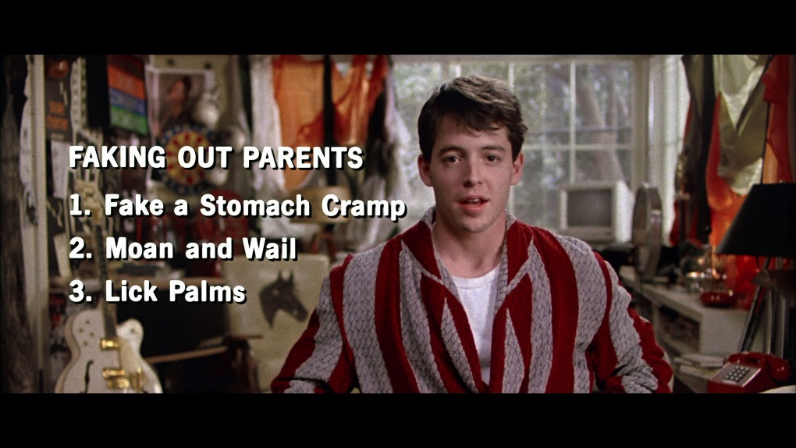

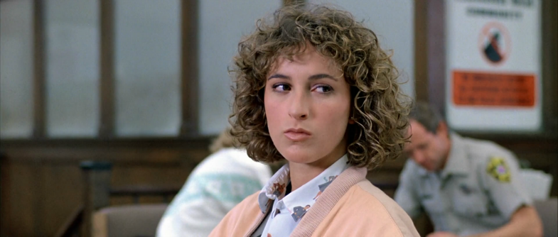

4

5

1

2

3

#

**Alan Ruck, who was supposed to be playing a high school senior was actually 29 years old when the movie was shot.**

Quick Fact

The Expert Says…

**Write text here.**

**Write text here.**



**Write text here.**

Take Note

Caption

5

2

1

3