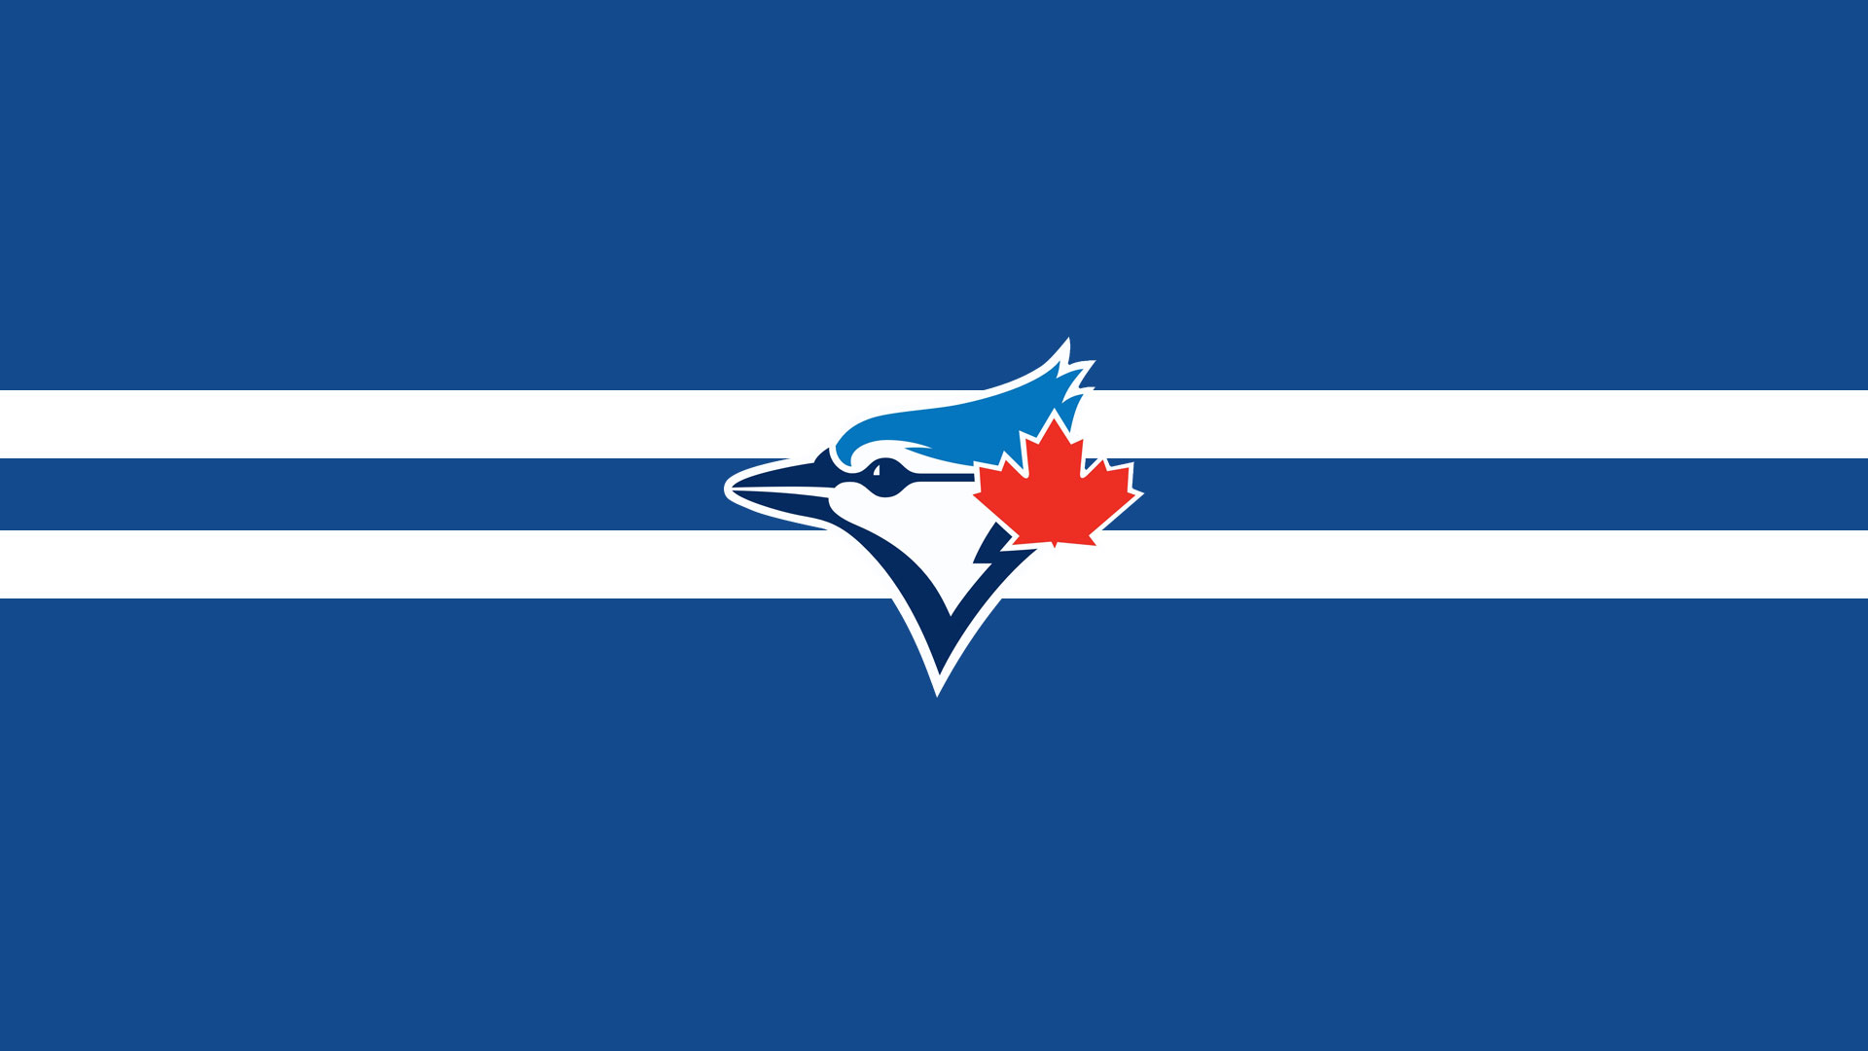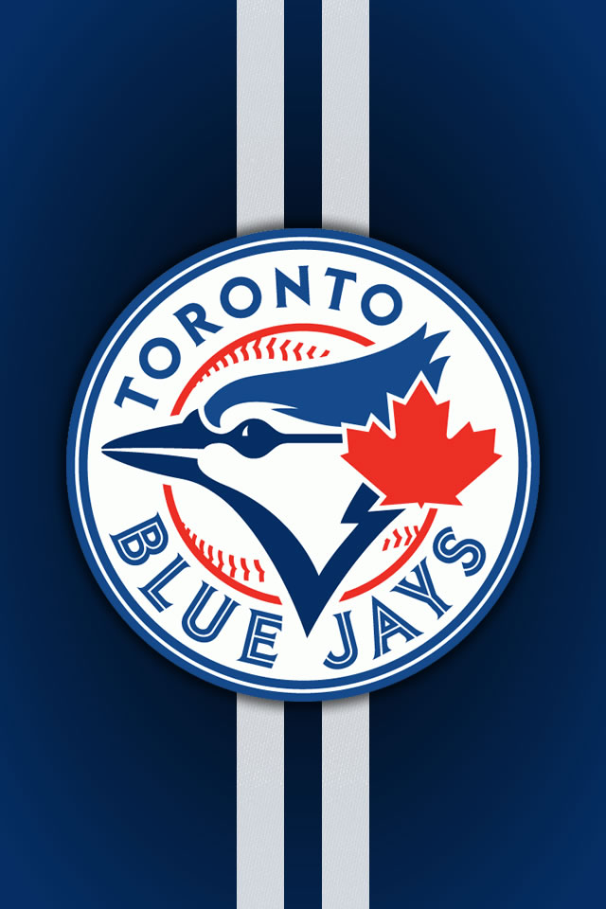

Ask a Canadian where they were when Joe Carter hit THAT homerun. I bet you’ll have an answer in seconds! The Toronto Blue Jays are currently the only MLB team we have. And throughout the past 38 years, some phenomenal players have worn the Jays uniform.

Find out records that were set, honours that were bestowed, and accomplishments made by the Jays. Learn about how they almost weren’t the Blue Jays and how far they have come.

**50 facts**

**Ms. K. Carter**

Contents

World Series

Awards

Hall of Famers

Level of Excellence

Records

2015 Season

In the Beginning

No Place Like Home

No Place Like A

New Home

Logos

Uniforms

Postseason



Published in 2015 at Petitcodiac Regional School

Editors: Emily Crosthwaite, Emma Davitt

Acknowledgements:

Thank you to all of my brilliant students for their input and their suggestions.

Dedication:

For Jose Bautista ☺ Nice home run!