[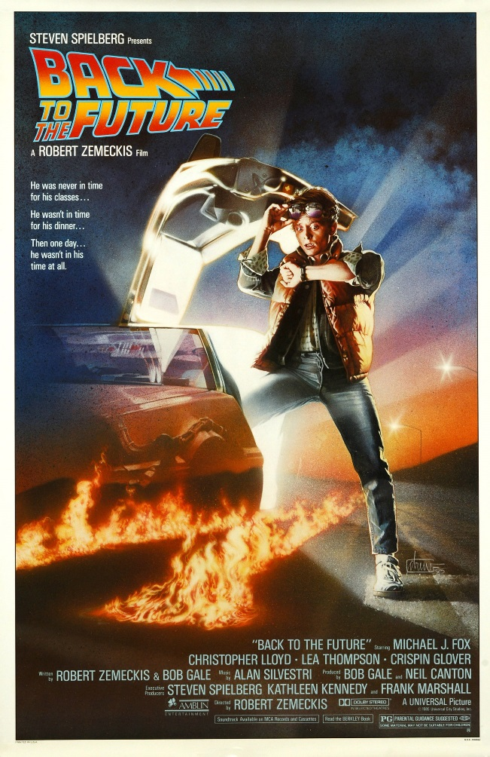](http://www.google.ca/url?sa=i&rct=j&q=&esrc=s&frm=1&source=images&cd=&cad=rja&uact=8&ved=0ahUKEwjKzeTKp8jMAhWMaD4KHVHtCSsQjRwIBw&url=http://www.banalleakage.com/2015/07/03/back-to-the-future-at-30/&bvm=bv.121421273,d.cWw&psig=AFQjCNGhhJqS61yjBXC7viob0qDnznYPdA&ust=1462719593604975)[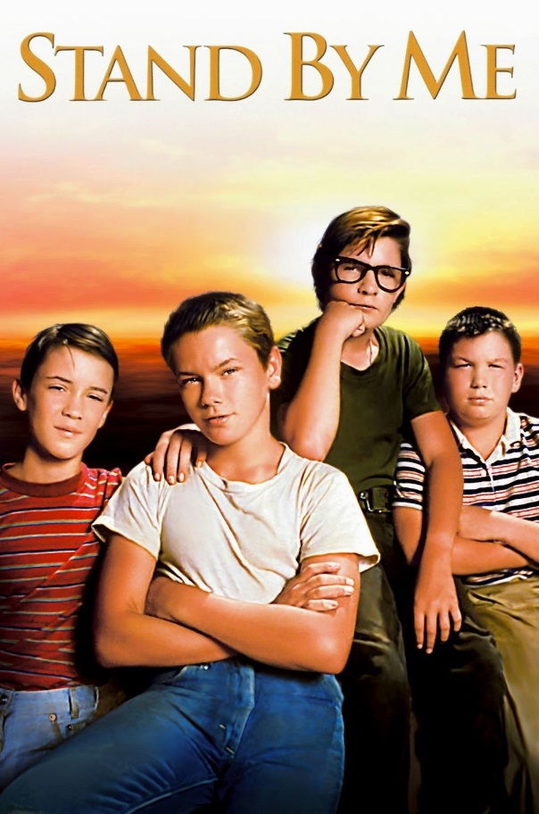](http://www.google.ca/url?sa=i&rct=j&q=&esrc=s&frm=1&source=images&cd=&cad=rja&uact=8&ved=0ahUKEwjx2fWLp8jMAhWEcT4KHc66BisQjRwIBw&url=http://m.imdb.com/title/tt0092005/mediaindex/?rmconst%3Drm2912857088%26ref_%3Dm_tt_ov_i&bvm=bv.121421273,d.cWw&psig=AFQjCNFY1ta59QIl5Fs3nOkgeHpxxdT6_Q&ust=1462719805215235)[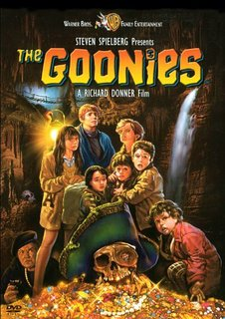](http://www.google.ca/url?sa=i&rct=j&q=&esrc=s&frm=1&source=images&cd=&cad=rja&uact=8&ved=0ahUKEwi56Ofmp8jMAhWKWT4KHXO1CCsQjRwIBw&url=http://www.amazon.com/The-Goonies-27x40-Movie-Poster/dp/B000VXAGRS&bvm=bv.121421273,d.cWw&psig=AFQjCNGiHsl9UIyQvYhEkCbXfCdOcVJQqA&ust=1462722421682723)[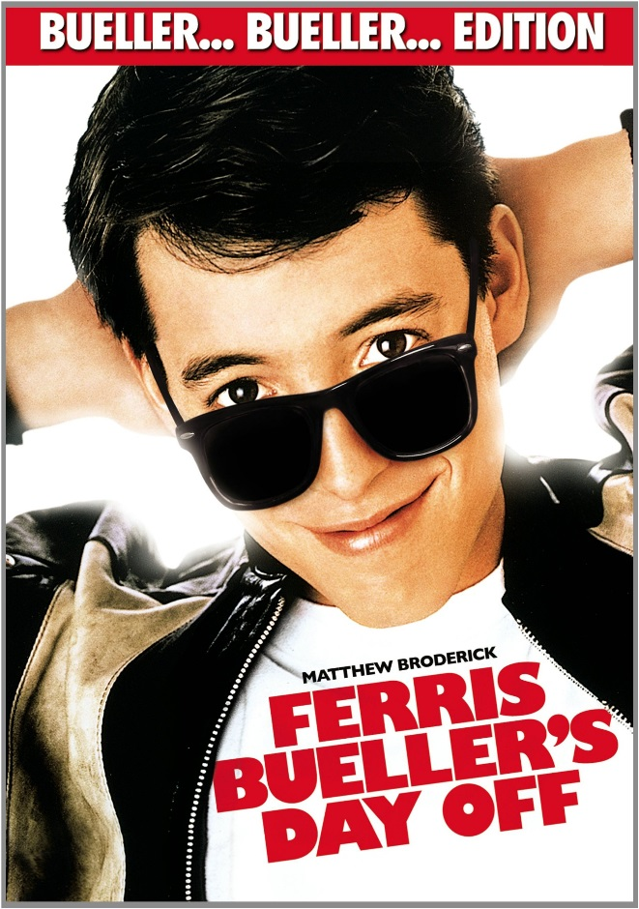](http://www.google.ca/url?sa=i&rct=j&q=&esrc=s&frm=1&source=images&cd=&cad=rja&uact=8&ved=0ahUKEwiusdaop8jMAhXEGD4KHeggCiwQjRwIBw&url=http://www.dvdsreleasedates.com/movies/841/Ferris-Bueller's-Day-Off-(1986).html&bvm=bv.121421273,d.cWw&psig=AFQjCNFxhPlE-g63EREwY-s_sec2jTdLhg&ust=1462719746541676)[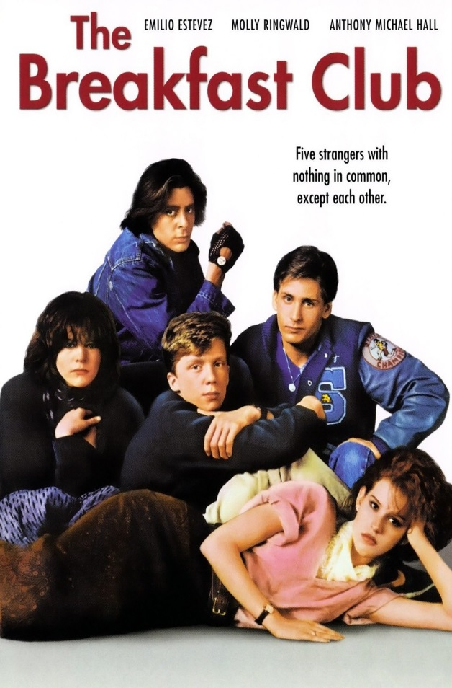](http://www.google.ca/url?sa=i&rct=j&q=&esrc=s&frm=1&source=images&cd=&cad=rja&uact=8&ved=0ahUKEwjYxaaEqMjMAhWBPz4KHYZRASsQjRwIBw&url=http://www.thefashionisto.com/the-breakfast-club-1980s-movie-styles/the-breakfast-club-original-movie-poster/&bvm=bv.121421273,d.cWw&psig=AFQjCNGp7h8Y_LcoeZEJ1WJ15tHfhcFRaA&ust=1462722482972542)

**Here are the criteria I used in ranking the most iconic teen movies of the 80’s.**

**The movie:**

* Made a lot of money at the box office
* Ratings
* Still celebrated
* Launched careers
* Won awards

**I thought…**

**1. Do you agree with my ranking? If you don’t, try ranking them yourself. Justify your ranking with data. You may use my criteria or you may use your own.**

**2. Here are others to consider: Pretty in Pink, Fast Times at Ridgemont High, Sixteen Candles, and Dirty Dancing. Fnd out more about them. Should they have made my list? Are there others that should be considered?**

**What do you think?**