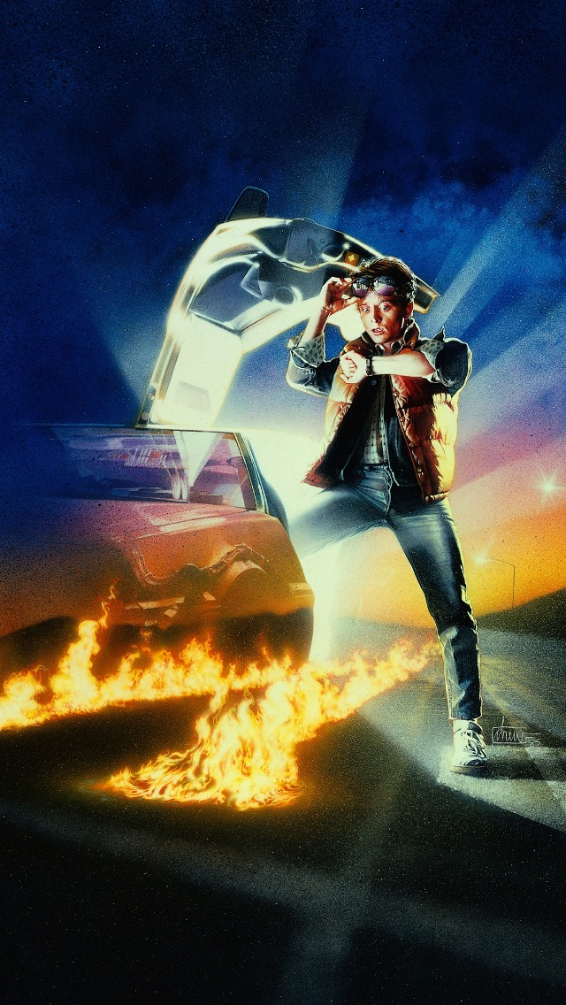

**MOST ICONIC TEEN MOVIES OF THE 80’S**



**Most Iconic Teen Movies of the 80’s**

**By Kandice Carter**